Link Scanner for Finding Dangling links and Patterns

Submitted to

International Institute of Professional Studies
Devi Ahilya University
Indore
2013

For IX semester of
Master of Computer Applications (6 years)

Internal: | Submitted By:
Dr. Kirti Mathur | Komal Rathore  (IC-2K9-40)  Misha P. Mathai  (IC- 2K9- 48)

CERTIFICATE

This is to certify that the project report entitled “Link Scanner for finding Dangling links and Patterns” carried out by Ms. Komal Rathore (IC-2K9-05) and Ms.Misha P.
Mathai (IC-2K9-21), is approved for the acceptance in partial fulfillment of IX semester MCA (6years).

Internal Examiner: External Examiner:
_______________ _________________

DECLARATION

We hereby declare that the project entitled “Link Scanner for finding Dangling links and Patterns” which is submitted by us for the completion of the requirement for IX semester of Master of Computer Application (6 years), to International Institute of Professional Studies, Devi Ahilya Vishwavidyalaya, Indore. This work has not been submitted anywhere else and comprises of our own work and due acknowledgment has been made in text to all in other materials used.

Signature of Student:
________________

Date: ___________________
Place: ___________________

ACKNOWLEDGEMENT

We acknowledge our sincere thanks to those who have contributed significantly to this project. It is a pleasure to extend deep gratitude to our internal guide Dr. Kirti Mathur, IIPS, for her valuable guidance and support and continuously inspired us for the progress of the project. We thank her for her valuable suggestions towards our project, which helped us in making this project more efficient and user friendly.

We thank and acknowledge each and every ones efforts that helped us in some or the other way for small and significant things.

Lastly we thank our parents who always motivated and stood by us without their blessing and constant support the project can’t be completed within due period.

ABSTRACT

“Link Scanner ” is a desktop based application. The aim of this project is to develop a system that provides summarized report of all dangling links and suspicious patterns found in urls’ of a website. The purpose of this project is to provide automated website testing tool for the administrators’ of websites. It saves manual effort and time of administrator .

Index

1.0. Introduction 7
1.1. Overview 7
1.2. Problem Definition 7
1.3. Aim 7
1.4. Objective 7
1.5. Scope 8
1.6. Goal 8
2.0. Current system and Proposed system 8
2.1. Current System and its Limitations 8
2.2. Proposed System and its advantages 8
2.3. Requirements 8
3.0. Feasibility Study 9
3.1. Economic Fesibility 9
3.2. Technical Feasibility 9
3.3. Behavioural Feasibility 9
4.0. Analysis 10

5.0.Planning 11
5.1. Assumptions and Constraints 11
5.2. Project Deliverables 12
5.3. Schedule 12
5.4. Team Structure 12
5.5. Gantt Chart 12
6.0. Design 13
6.1. Usecase 13
6.2.Sequence Case 16
6.3. Data Flow Diagram 17
6.4. Activity Diagram of scanner 19
6.5. Class Diagram 20
6.6. Logical Design 22
6.7. Interface 22
7.0. Testing 24
8.0. Future Perspective 25

Bibliography and Glossary 25
Reference 26

- INTRODUCTION
  - Overview
Link Scanner is developed for administrators of website so as to manage website efficiently by removing broken/dangling links and links with suspicious patterns. This system is a desktop based application, which is open source and freely available to download and use. It will helpful for managing and maintaining website over long duration.
  - Problem Definition
- Customer faith on site decreasing
- Negative publicity of Site and goodwill of company does not last.
The above stated problems are quite common these days. The reason is ,the content of website contains improper text ,images, broken links and other scripts, which redirect the customer to wrong websites ,alter the system behavior due to virus /malicious code because of which the customer trust and interest is lost. It leads to negative publicity of website .It results in low website traffic.

  - Aim
Aim of our project is to develop a Link Scanner, website testing tool that can be used by the administrator of websites.
  - Objective
The objectives of our project are stated below:
- Crawler to extract the links from the web page.
- Check webpages of website for 404 errors and other unsuccessful HTTP response codes - for each dead or problematic hyperlink.
- Reports list of dead links and their location.
- Find malicious patterns in links (url).
- Create a summarized report in PDF file along with performance details.
- Show Report to the admin.
  - Scope
Link scanner is a desktop based application. It can be used as a website testing tool by administrators of website.
  - Goal
Build integrated Link Scanner system with functionalities of link extractor, link checker and scanner.

- Current System and Proposed system
  - Current System and its limitation
For an individual, it might be feasible to check every link of website manually, this would be very time consuming and would be impractical for most websites. The obvious solution is to employ link checking tools, to check all the links automatically.

  - Proposed System and its Advantages
Proposed system automatically scans for various patterns in a URL and checks for dangling /broken links of website using a single click .It is open sourced and will be freely available to end users.

  - Requirements
System requirements
    - Operating System: Windows xp,Linux(Ubuntu )
    - Processor: P2 or higher
    - RAM: 256 Mb minimum. ,Hard Drive: 5 GB or more
    - Internet connection
    - Other basis components of computer: keyboard, mouse, printer etc.
    - PDF Reader
    - Python 2.7.2

- Feasibility study
  - Economic Feasibility
This project can be regarded as economically feasible because there is no need of bearing any cost on the resources needed for the development of the system as we are working open source technologies. The only resource required for proper and successful working of this system is internet connectivity.

  - Technical Feasibility
In our project the technical feasibility is considered up to a great extent. The software is build using Python. It provides good Graphic User Interface and libraries for the system.. Proposed system can be expanded in future if required.

  - Behavioral Feasibility
The proposed system-Link Scanner is convenient to maintain, Effective in its work and Easy to operate. No specific user training is required to operate this software .It is user friendly in all ways. With one click user can get all details required which is far better than the manual system. It also produces report that will be helpful in effective and efficient decision making.

- Analysis
The following table provides an "at-a-glance" comparison of link checker tools (click on the tools for a more detailed review):
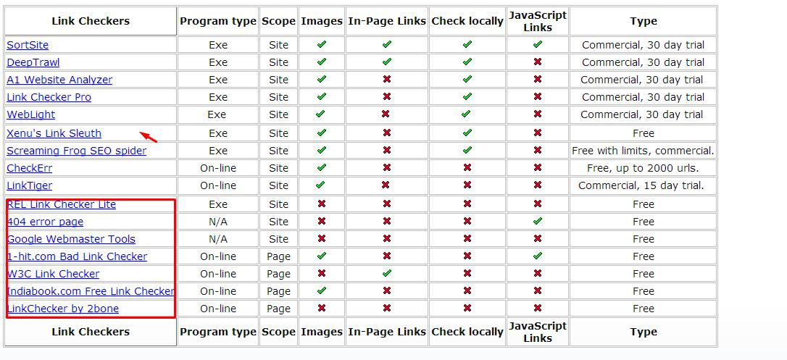

Program type
Indicates whether the link checker must be downloaded and run ("Exe") or whether it can be run by connecting to a website ("on-line").
Scope
Whether the link checker checks an individual page ('page') or an entire web site ('site').
Images
Whether the link checker checks for missing images. A missing image is an image that simply isn't there. Typically these will appear in a browser as a box like this: "" (quotes added)
Check locally
Whether the link checker can examine a website which is resident locally on disk, or whether the web site must be on the web to be checked.
In-Page Links
Whether the link checker checks links on a page to bookmarks within that same page. This is an example of a local link: "<a href="#Top">Top</a>" and this is an example of a broken local link "<a href="#Broken">Broken</a>". One significant difference between a broken link and a broken in-page link is that the user won't see an error if an in-page link is broken - clicking on the link just won't do anything. In-page links are also known as "local links" and "fragments".

Conclusion: As we can analyze from the above table none of the link checkers provide the functionality of full site search, local links checks and In-page link checks for free!!Thus, our link scanner which contains functionalities of link extractor,link checker and scanner will be open sourced so that it can be freely used.

- Planning
  - Assumption & Constraints
The assumptions of this project are as:
- Software is used by the administrator of website.
- We have patterns list against which links are checked.
- By default the depth of crawling is 2.
- We have two types of links External links and internal links. External Links which is start with http:// and internal link start with /.
- Our System is works on the External links.
- Our admin has Pdf Reader installed in his/her system.
The Constraints of this project are as:
- System will only scan websites on client server architecture.
- It will crawl a link only once.
- Net connection should be available to the user
- It only searches for dangling links and links with malicious patterns.
- The system will not check links specified in comments.

  - Project Deliverable
The list of project deliverable is
- Project management plan
- Software Requirement plan
- Software design plan
  - Schedule

Work Product | Delivery Date
Project plan (SPMP) | 31 August 2013
Supporting process Requirement (SRS) | 7 September 2013
Design Documentation (SDD) | 21 September 2013
Demo | 26 November 2013
Project file | 16 December 2013
Final Project Demo | 18 December 2013

  - Team Structure
Our team structure is as:
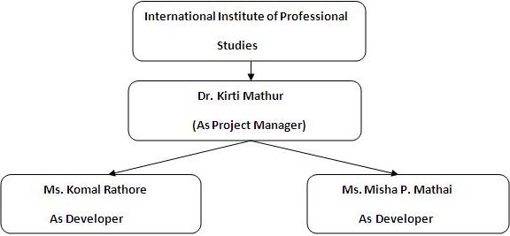

  - Gantt chart

M1- Link Extractor→ 7- 8 days
M2 - Link Checker→ 15 days
M3- Link Scanner→ 5 days
M4 - PDF Generator → 4 days
M5 – Mailer → 5 days

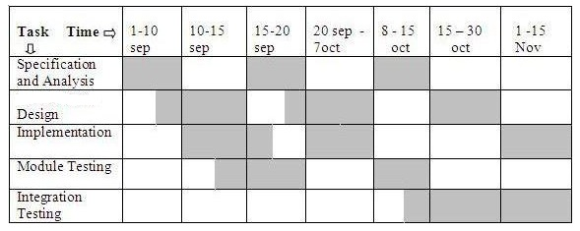
- Design
  - Use case of the system is as:
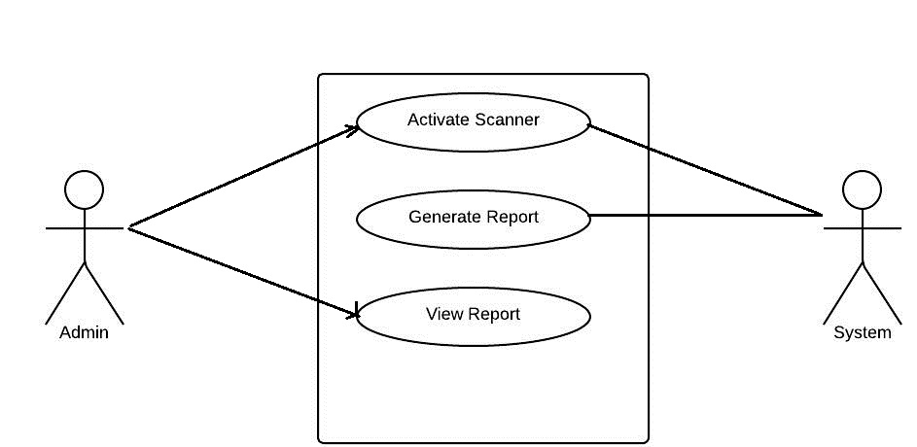
Use Case Description
- Activate Scanner use case specification

Use Case Name: Activate Scanner
Primary Actor: Admin, System
Stakeholders and Interests: Admin scan the website for detecting the broken and links containing malicious patterns.
Brief Description: This use case describes how Admin activates the scanner.
Trigger: When user enters the URL in the textbox and click on the Start
Scan button.
Extends: Generate Report, View Report
Pre-condition : Internet connectivity is required.
Post-condition: Admin can close the system by clicking Quit button.
Normal flow of events:
- The Admin enters URL and clicks on the Start Scan button.
- The system validates the URL.
- The System then starts the scanning process and send results to Generate Report Use Case.
Alternate / Exceptional Flows:
1a. The User does not fill the URL correctly and then message is display
3a. The admin wants to stop the scanning process.
- Generate Report use case specification

Use Case Name: Generate Report
Primary Actor: System
Stakeholders and Interests: To generate the summarized report for admin.
Brief Description: This use case describes how system generates the report from result of Activate Scanner Use Case.
Trigger: When System completes scanning the report is generated.
Extends: View Report
Pre-condition: Activate scanner
Post-condition: Admin can close the system by clicking Quit button.
Normal flow of events: After completion of scanning process System automatically generates a report.
Alternate / Exceptional Flows:
- The admin wants to stop the scanning process.
- Does not Generate report in case of system shutdown, System restart; internet connection is lost during scanning process.
- View Report use case specification

Use Case Name: View Report
Primary Actor: admin
Stakeholders and Interests: To view the summarized report.
Brief Description: This use case describes how user views the report.
Trigger: When Report is generated admin can view report.
Extends: None
Pre-condition: Activate scanner, Generate report
Post-condition: Admin can close the system by clicking Quit button.
Normal flow of events: After completion of scanning process System automatically generates a report. And admin can view report.
Alternate / Exceptional Flows:
- The admin wants to stop the scanning process.
- Does not Generate report in case of system shutdown, System restart, internet connection is lost during scanning process

  - Sequence Diagram
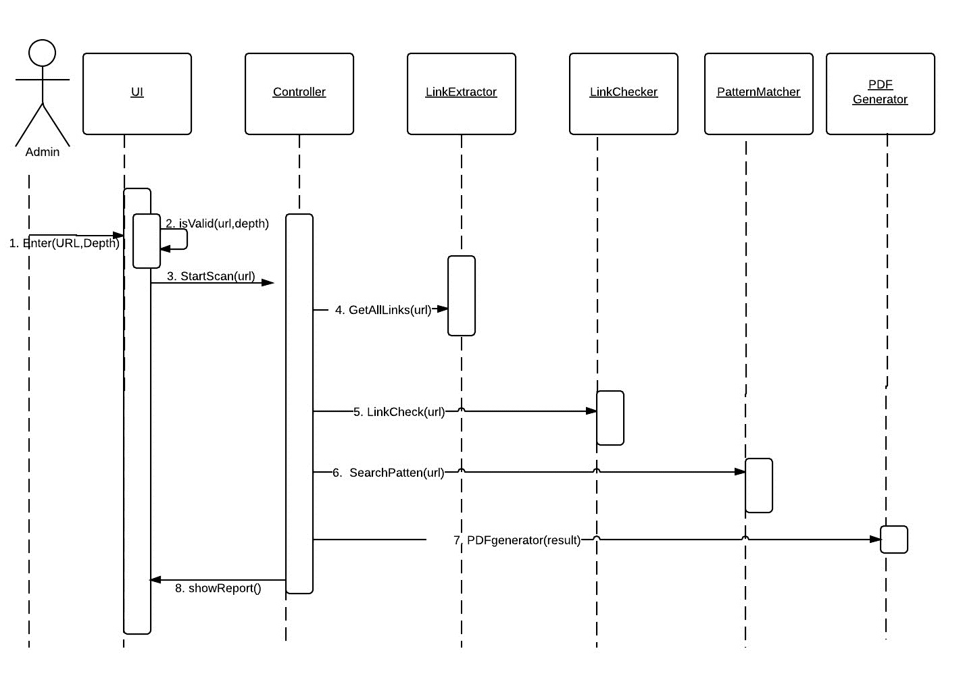
Description:Admin enters the url .The entered url is validated ,if the url is not valid admin has to re-enter the input url else scanning process starts .Links are extracted using link extractor,which returns list of links to controller .Next,controller sends result list to link-checker .Link checker checks for broken /dangling/dead links in result list and returns updated result list to controller.Controller then sends result list to scanner,which checks result list (urls) against a set of patterns.Scanner returns result list with identified patterns to controller.Controller then sends the list to pdf generator to generate report.

Data Flow Diagram
DFD 0
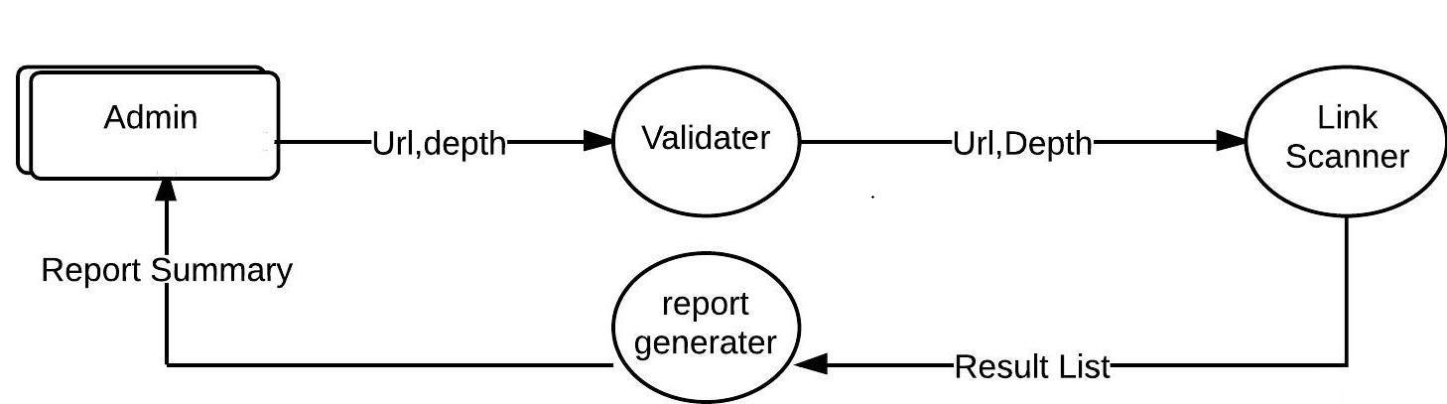
DFD 1
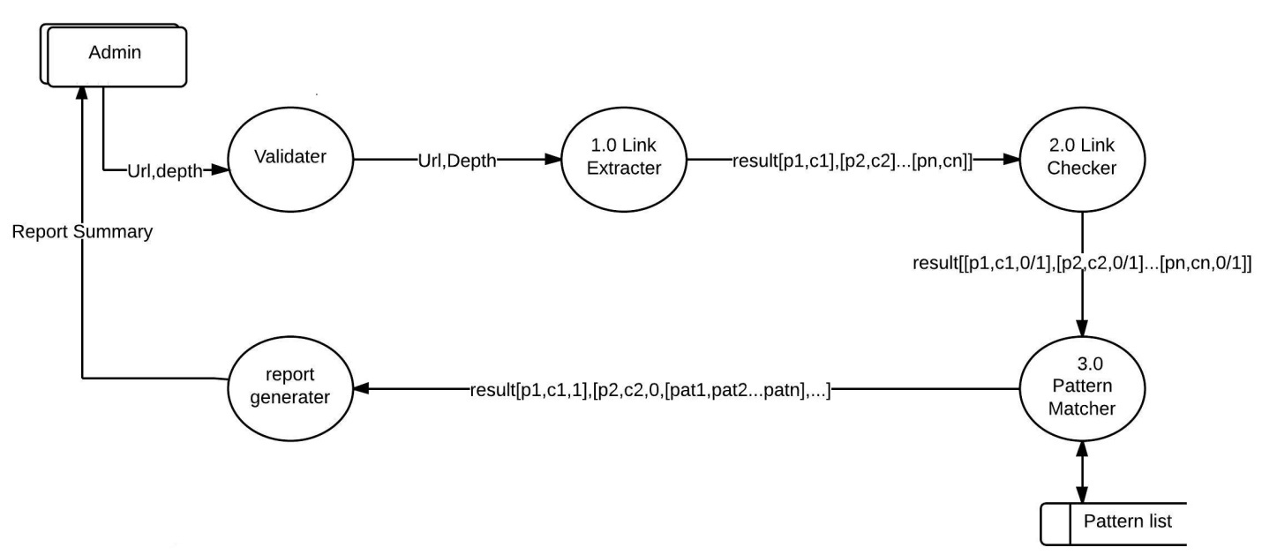

Admin: Admin is the external entity which interacts with the system enters the inputs and views the summarized report generated by the system.
Validator: It validates the input URL and Depth.
Result list: It is the dynamically generated list has the array of structure, and structure element contains the following elements.
Parent link: A link whose page contains the links. It is indicated by pn where n>=1
Child link: A link which is contain in the parent page. It is indicated by cn where n>=1
Link Status: It has value either 0 or 1. 1 shows broken link and 0 shows not broken links.
Pattern List: It shows the list of pattern finding in the URL.
Link Scanner: It takes the input URL, Processes it and gives the result list. In data flow diagram level 1, it is decomposed into three sub processes Link extractor, Link checker and Pattern matcher.
Link Extractor: Extract all the links up to given depth and store this links into parent child page relationship. And return the result list.
Link Checker: The result list return from Link Extractor, it checks for broken or dangling links in the child element.
Pattern matcher: It matches the patterns against the links and if match occur it update the result list else it does not update it.
Report Generator: It takes the output of Link scanner and generates report. The report Summary contains the following:
- Pattern name and Pattern found in Links
- List of broken links.
- Complete List of Dangling/broken Links and Patterns
- Performance Details.
  - Activity diagram for Scanner
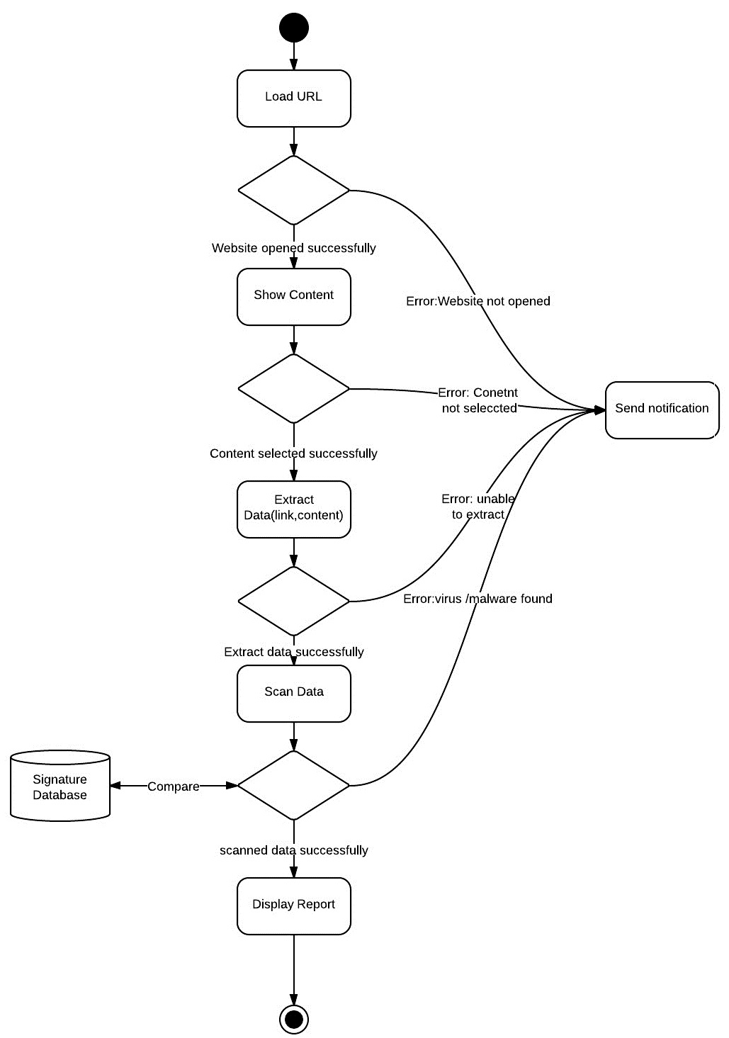

  - Class Diagram
The purpose of this diagram is to show how objects within the Link Scanner will interact with each other in order to achieve the functionality required by the Use Case diagram. 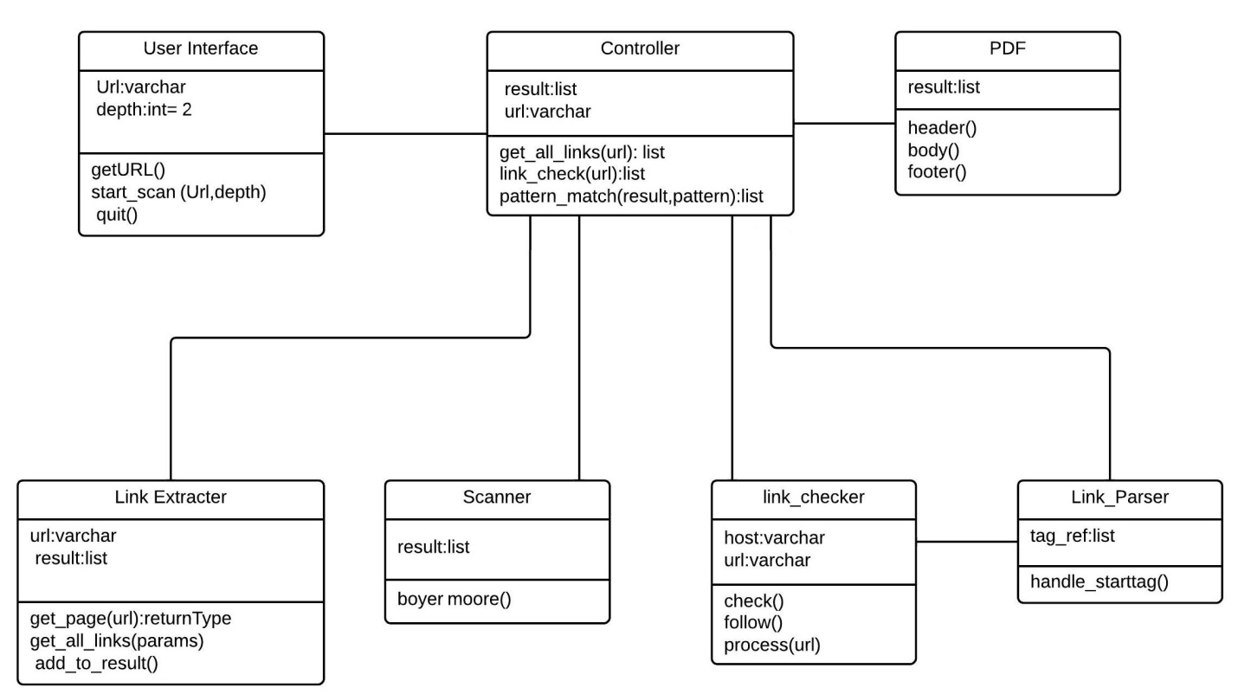
Class Name | Description
User Interface | It is the boundary class that interacts with the system and user.
 | Variables:url,depth
 | Functions:getURL(),start_scan(url,depth),quit()
Controller | It is class that interacts with all other classes (link checker,link extractor,pdf and scanner).It controls the overall system.Controller updates the result list.
 | Variables:result,url
 | Functions:get_all_links (url),link_check(url),pattern_matching(url,pattern)
Link Extractor | This class extracts links from parent page and their respective child pages..
 | Variables: url,result;
 | Functions: get_page(url),get_all_links(),add_to_result()
Link Checker | This class checks the page for broken links. It uses link parser class for content-type information of a webpage.
 | Variables: host,url
 | Functions: check(url),follow(),process(url)
Scanner | This class scans url against a set of patterns.
 | Variables: url, pattern []
 | Functions: boyer_moore ()
PDF | This class helps in generating reports.
 | Variables: title,date, time,result[],
 | Functions: header(),body(),footer()
  - Logical Design
The graphical user interface of the system is designed using python library tkinter. The system is developed using python programming language.

  - Interfaces

Our User Interface contains the following element Textbox, Quit button, Start button, View report Button, Progress bar, Window close button

- Initial State :
Element Name Visibility
Textbox normal
Quit button normal
Start button normal
View reports Button disable
Progress bar disable
Window close button normal

- Start State
Element Name Visibility
Textbox normal
Quit button normal
Start button normal
View report Button disables
Progress bar disable
Window close button normal

- Active State
Element Name Visibility
Textbox normal
Quit button normal
Start button disable
View report Button disables
Progress bar normal
Window close button normal

- Stop State
Element Name Visibility
Textbox normal
Quit button normal
Start button normal
View report Button normal
Progress bar disable
Window close button normal

- Terminate State
Element Name Visibility
Textbox normal
Quit button normal
Start button normal
View report Button disable
Progress bar normal
Window close button normal

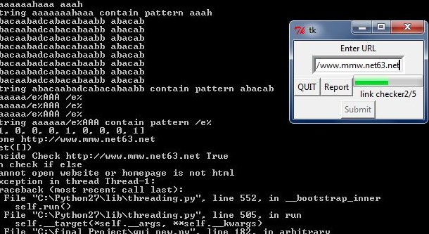

- Testing
Validations used: validation on url:
-It can’t contain null or empty value
-It can consist of character from 0 to 255(ASCII)
-Can be uppercase or lowercase.

SNO | Module Name | Test case name | Valid Input | Valid output | Detected by | Status Resolve /Not resolve
1 | Link Checker | Find all external broken links | http://www.kryer.co.uk/no_such_page.htm | Broken link | komal | resolved
 |  | Finding internal broken links | http://www.mmw.net63.net/follow.html | Broken link | komal | resolved
 |  | Finding Internal broken of external non broken links | http:External/internal | - | Komal and misha | Not resolved
2 | Link scanner | Find the pattern containing special symbol | !@#ddD322!@# | None | Misha | Resolved
 |  | Length of pattern greater than length of url. | lknlksabnlnj@@I am pattern>?#8*@)?###****^^ee mkk | -1 | komal | resolved
3 | LinkExtracter | Extract link in the anchor tag | <a  href=”abc.html”> | Link extracted | Misha | resolved
 |  |  | <ahref= “abc.html”> | - | komal | resolved
 |  |  | <a href = “abc.html”> | Link extracted | komal | resolved
 |  |  | <a href =”abc.html”> | Link extracted | Misha | resolved
 |  | Not extract links inside the comments | <!-- <a href=”abc.html”></a> | - | Misha | resolved
 |  | Depth test | -1 | - | komal | resolved
4. | PDF Maker | Length of pdf name | “Report” | Fixed name | Misha | Resolved*
 |  | Generating of pdf without installing PDF Reader |  | Error :install pdf reader | komal | resolved
5. | GUI | After click on Start Button | Click on start scan | Validation process starts | Misha and komal | resolved
 |  | Input field should be non empty | - | Please enter url | Misha and komal | resolved
 |  | Input field should contain the valid url | http://www.mmw.net63.net | Scanning process starts | Misha and komal | Resolved
 |  | Length of Input field | Less than 100 | Validation process starts | Misha and komal | Resolved

8.Future Perspective
The project can be further extended :-
- The current system only works for websites developed on client server architecture, the link scanner can be further extended to scan on websites with MVC architecture.
- Specialized crawler for browsing contests(Use of system for keyword search in web.).
- Link scanner for missing images.
- Link scanner checks links generated using JavaScript

BIBLIOGRAPHY & GLOSSARY
- [01] Elias M. Awad , System Analysis and Design, IInd edition 2009, Galgotia Publication Pvt. Ltd, New Delhi.
- [02] Information practice (for visual basic)Xii
- [03] Software Engineering (Pankaj Jalote)
- IEEE Guide to Software Design Description (Std 830-1993).
- A handbook guide of SDD(E-Book).
- UML and the Unified Process: Practical Object-oriented Analysis and Design by Jim Arlow & Ila Neustadt.
- Software Testing by Ron Patton

Term | Definition
Admin | Administrator of website
url | Universal Resource Locator
Link | <a href =”I am link.html”></a>
Internal Link | Subpages/inner pages of a website.
External Link | Links that refer to other websites.
Report | Pdf document
Broken/bad | Links with client side and server slide error like 404 error ,501 error etc.
Malicious/suspicious pattern | Harmful patterns which symbolize existence of virus.
MVC | Model View Controller Architecture
Signature database | Database with all malicious patterns and links.
Gui | Graphical User Interface

REFERENCES
- http://onlinelinkscan.com/
- http://www.avg.com.au/resources/web-page-scanner/
- http://vms.drweb.com/online/?lng=en
- http://www.cryer.co.uk/resources/link_checkers.htm

